 | School: Cam Van Primary School  Name:  Class: |  |  |  |  |  |  |  | THE SECOND SEMESTER TEST  SUBJECT: ENGLISH - GRADE 4  SCHOOL YEAR: 2023 - 2024  Time: 40 mins
Mark |  | Listening |  |  |  | Reading and Writing |  |  |  |  |  | Speaking | Total
 |  | Q1 | Q2 | Q3 | Q4 | Q5 | Q6 | Q7 |  | Q8 | Q9
Comment:

PART I: LISTENING (15’)
Question 1: Listen and number (1pt)
  A |   B |   C |   D
Question 2 : Listen and match (1pt)
  A |   B |   C | D

1 ______ 2 ______ 3 ______ 4_______

Question 3: Listen and write (1pt).

0. | I want to buy somebooks . | 
1. | Let’s go to the_____________________________
2. | Her sister works in a __________________
3. | I like these __________________________________
4. | There is a __________________ near my house.

Question 4: Listen and put a tick () or cross ( X ) in the box (1pt)
- She cleans the floor on Thursday.
- The bakery is opposite the cinema.
- I like elephants because they run quickly.
- They go to the bookshop to buy some books.

PART 2. READING AND WRITING ( 15 minutes)
Question 5: Look and read .Put a tick ( ) or a cross () in the box. (1 pt)
-  | - They’re crocodiles.
-  | 1. The weather was windy.
2. 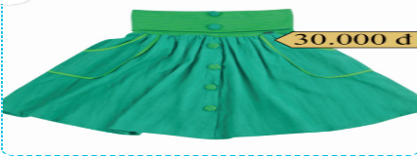 | 2. The dress is thirty thousand dong.
3.  | 3. He works in the hospital.
4.  | 4. He is a factory worker.
Question 6. Read and tick Yes or No (1pt)
At weekend, Mai goes for a walk with her friends in the mountains. They want to relax and enjoy the scenery. The girls like playing badminton. The boys enjoy swimming in the stream. Mai has a new mobile phone and she likes taking photos with it. The children love having lunch together.
0. Mai goes for a walk with her friends in the countryside. | Yes | No
1. They want to relax and enjoy the scenery in the mountains.
2. The girls like playing badminton.
3. The boys dislike swimming in the stream.
4. Mai likes taking photos with her mobile phone.
Question 7: Look at the pictures and the letters. Write the words (1pt)
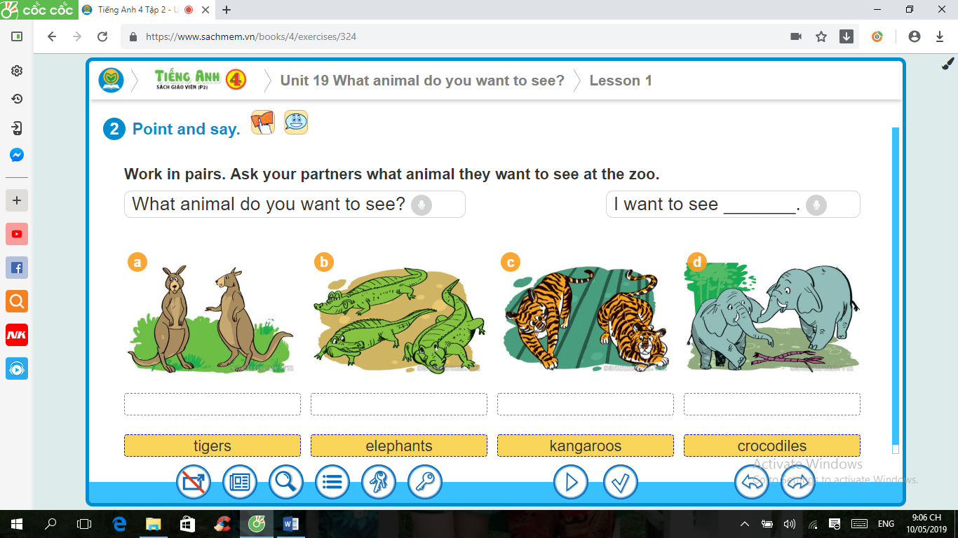  1. eslphetan → _______________ | 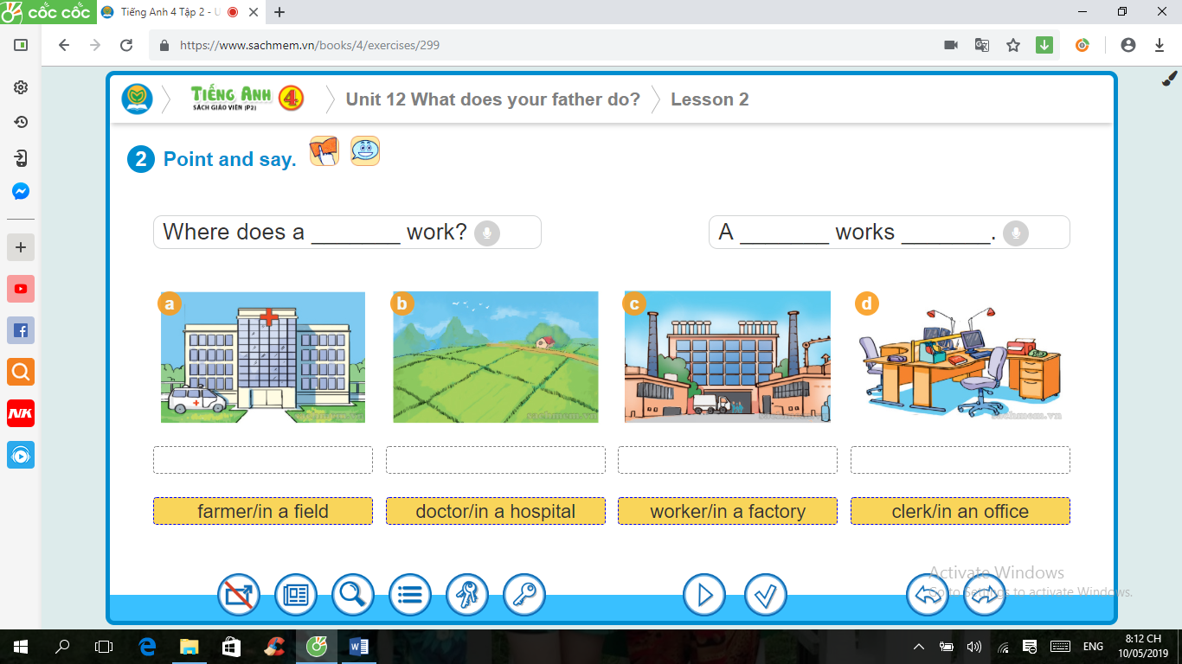  2. oshipalt → ______________
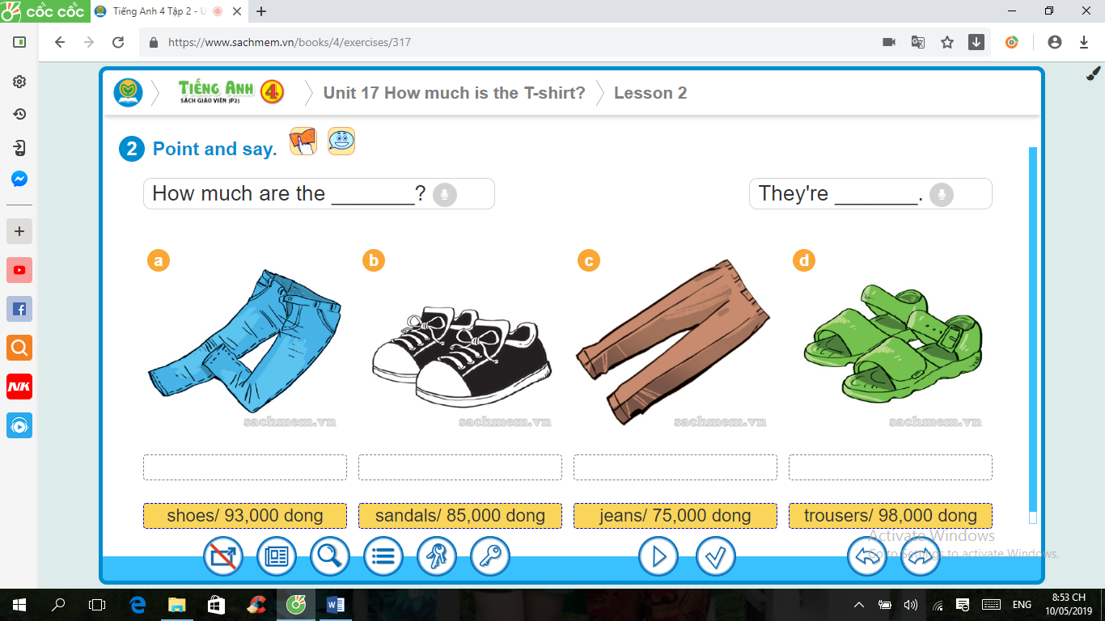  3. osehs → _________ | 4.  teBeewn →_____________

Question 8: Fill in each gap with a suitable words from the box (1pt)
picnic next to campsite sunny swim
It was (0) ___sunny___ all day yesterday, but it is hot and sunny today. We went to
the (1)___________. It is (2) ____________ the Sarah river. It’s quite near our house so we walked to get there. Many people want to go there to (3) _________ in the river and take photos. At the camp, we had a nice (4)___________
Question 9. Reorder the words to complete the sentences (1pt)
1. was / the / What / like / yesterday ?/ weather /
…………………………………………………………………………………..
2. Amsterdam / get / to / I / How / primary / can / school? /
…………………………………………………………………………………..
3. between / The café / the / is / gift shop / the shoe shop . / and /
……………………………………………………………….………………….
4. the animals. / They are / want to / they / because / at the zoo / see /
………………………………………………………………………………….
PART 3: SPEAKING (1pt)
1. Listen and repeat 2. Point, ask, answer
3. Listen and comment 4. Interview
___Hết___
Giáo viên coi kiểm tra  (Ký, ghi rõ họ tên) | Giáo viên chấm kiểm tra  (Ký, ghi rõ họ tên)
………………… …………………

TRƯỜNG TIỂU HỌC CẨM VĂN | KEYS TO THE END SEMESTER TEST  English – Grade 4 – School year: 2023 – 2024

ĐÁP ÁN VÀ HƯỚNG DẪN CHẤM - TIẾNG ANH LỚP 4 CUỐI KÌ II
NĂM HỌC 2023 - 2024
Question | Answer |  |  |  | Point | Total
1 | 1.B | 2.C | 3.A | 4.D | 0,25/each | 1pt
2 | 1.B | 2.A | 3.C | 4.D | 0,25/each | 1pt
3 | 1. food stall | 2. factory | 3. peacocks | 4.swimming pool | 0,25/each | 1pt
4 | 1. | 2.X | 3.X | 4. | 0,25/each | 1pt
5 | 1. | 2.x | 3. | 4. | 0,25/each | 1pt
6 | 1. Y | 2.N | 3.Y | 4.Y | 0,25/each | 1pt
7 | 1.elephants | 2. hospital | 3.shoes | 4.between | 0,25/each | 1pt
8 | 1.campsite | 2. next to | 3.swim | 4. picnic | 0,25/each | 1pt
9 | - What was the weather like yesterday? |  |  |  | 0,25/each | 1pt
 | - How can I get to Amsterdam primary school?
 | - The café is between the gift shop and the shoe shop.
 | - They are at the zoo because they want to see the animals

____ Hết___

TRƯỜNG TIỂU HỌC CẨM VĂN | TRANSCRIPTS FOR LISTENING  English – Grade 4 – School year: 2023 – 2024
BÀI NGHE MÔN TIẾNG ANH LỚP 4 CUỐI KÌ II NĂM HỌC 2023- 2024
Question 1: Listen and number (1 point)
1. A:Where did you go yesterday?  B: I went to the bakery. | 2. A: How can I get to the zoo?  B: Go straight.
3. A: What does your brother do?  B: My brother is an actor | 4 . A: Where are you going ?  B: I’m going to the shopping mall.
Question 2 : Listen and match (1 point)
1. A:How much is the cap?  B: It’s twenty thousand dong. | - A: How much are the trousers?  B: They’re two hundred fifty thousand dong.
- A: What is this ?  B: It’s a sweater  A: How much is it?  B: It’s one hundred thousand dong. | - A: What do you want to buy?  B: I want to buy a skirt
Question 3: Listen and WRITE (1 point)
- I want to buy somebooks .
- Let’s go to thefood stall
- Her sister works in a factory
- I like these peacocks
- There is a swimming pool near my house.
Question 4: Listen and put a tick ( ) or cross () in the box
- She cleans the flooron Thursday.
- The bakery is next to the cinema.
- I like lions because they run quickly.
- They go to the bookshop to buy some books.
____The end____
 |  | MA TRẬN ĐỀ KIỂM TRA
TRƯỜNG TIỂU HỌC CẨM VĂN  ________________ |  | CUỐI HỌC KÌ II MÔN TIẾNG ANH LỚP 4  NĂM HỌC 2023-2024

Kỹ năng | Nhiệm vụ đánh giá/kiến thức cần đánh giá | Mức/Điểm |  |  |  | Tổng số câu, số điểm, tỷ lệ %
Nghe |  | M1 | M2 | M3 | M4 | 16 câu  4 điểm  40%
 | Listen and number | 2  0,5đ | 2  0,5đ
 | Listen and match | 1  0,25đ | 2  0,5đ | 1  0,25đ
 | Listen and write | 1  0,25đ | 2  0,25đ | 1  0,25đ
 | Listen and put a tick ( ) or cross () in the box |  | 2  0,5đ | 2  0,5đ
Đọc | Look and read .Put a tick ( ) or a cross () in the box | 1  0.25đ | 2  0,5đ | 1  0,5đ |  | 12 câu  3 điểm  30%
 | Read and tick ( ) Yes or No |  | 1  0.25đ | 2  0,5đ | 1  0,25đ
Viết | Look at the pictures and the letters. Write the words . |  | 1  0.25đ | 2  0,5đ | 1  0,25đ | 8 câu  2điểm  20%
 | Fill in each gap with a suitable words from the box |  | 2  0,5đ | 2  0,5đ
 | Reorder the words to complete the sentences | 1  0,25đ | 2  0,5đ | 1  0,25đ
Nói | Getting to know each other |  | 2  0,5đ |  |  | 4 câu  1 điểm  10%
 | Talking about familiar object |  |  | 1  0,25đ
 | Describing the picture |  |  |  | 1  0,25đ
Tổng |  | 6 – 15% | 18 – 45% | 12 – 30% | 4 – 10%

